# Acronyms

* **AI** - Artificial Intelligence
* **CNN** - Convolutional Neural Network
* **LSTM** - Long Short-Term Memory
* **MRI** - Magnetic Resonance Imaging
* **X-ray** - X-radiation
* **CT** - Computed Tomography
* **NLP** - Natural Language Processing
* **API** - Application Programming Interface
* **ROCO** - Radiology Objects in Context
* **ML** - Machine Learning
* **DL** - Deep Learning
* **UI** - User Interface
* **UX** - User Experience

# Nomenclature

* + **Artificial Intelligence (AI)** – Computer science field with the study of creating machines capable of performing activities based on human intelligence, such as learning, reasoning, perception, and language understanding.
  + **Convolutional Neural Network (CNN)** – Deep learning architecture well-posed to work with grid-based data like images. CNNs are used within the project for feature learning from medical images like X-rays and MRIs.
  + **Long Short-Term Memory (LSTM)** – A Recurrent Neural Network (RNN) architecture that can learn long-term dependency from sequential data. It has been employed in an attempt to generate natural language annotations from the learned features of the medical images.
  + **Natural Language Processing (NLP**) – a branch of the artificial intelligence that deals with getting computers to process, learn, and generate natural language. NLP is interested in translating visual information into text.
  + **Magnetic Resonance Imaging (MRI)** – A radiological imaging modality that creates highly accurate images of the body's internal structures using magnetic fields and radio waves.
  + **X-ray** – Diagnostic imaging technique using electromagnetic waves to produce views of the interior of the body, specifically bones and lung cavities. Deep Learning (DL) – A type of machine learning that employs multi-layer neural networks to estimate complex patterns in large datasets. Graphical User Interface (GUI) – A graphical user interface by which the user interacts with the system via graphical objects such as buttons, forms, and image viewers. Flask – A web framework for Python utilized in creating the frontend part of the system, for instance, image uploading and real-time caption displaying.
  + **Dataset** – An organized set of data. It is a set of medical images and text data that are utilized to train and test the model here.
  + **Feature Extraction** – Isolation and extraction of meaningful visual data from an image, as identified by CNNs in this work.
  + **Caption Generation** – The semiautomatic creation of semantically accurate textual image captions by utilizing AI models able to recognize visual as well as text patterns.
  + **Annotation** – The activity of adding images with descriptive data or metadata, needed to train supervised learning models.

# List of Figures

|  |  |
| --- | --- |
| **Figure Number** | **Page No.** |
| Figure 1 | 17 |
| Figure 2 | 17 |
| Figure 3 | 18 |

**CHAPTER 1: INTRODUCTION**

The innovation of artificial intelligence (AI) in the health sector has seen tremendous improvement in diagnostics, therapy, and treatment of patients. Some of the improvements include image analysis medical image AI-based systems, which is a groundbreaking software, particularly radiology. Medical images such as X-rays, MRIs, CT scans, and ultrasounds have a huge amount of visual data which need to be interpreted by doctors. But the traditional method of interpreting these images manually is arduous and prone to error. Clinicians and radiologists have to work under extreme pressure to read many images in a limited span of time, and at times it results in error or late diagnosis.

The more medical images are generated, the more and more challenging it becomes for physicians to maintain their diagnostic process as precise and efficient as possible. To this challenge, the need for systems that will automatically interpret medical images and provide useful text descriptions becomes increasingly urgent. A computerized artificial intelligence caption generation system will be of utmost importance to address these issues by providing a high-quality, accurate, and scalable solution for image analysis and documentation.

It is an advanced deep learning-based system, i.e., Convolutional Neural Networks (CNNs) and Long Short-Term Memory (LSTM) networks. CNNs are renowned for their ability to learn features from images through the detection of patterns and structures, leading to their use in processing complex medical images. In medical image captioning, CNNs scan images in order to extract meaningful features such as anatomical structures, lesions, or abnormalities. Once these features are recognized, the LSTM network is utilized by producing natural language captions based on visual cues provided by the CNN. The LSTM is well-suited to this task because it can maintain the grammatical and contextual structure needed in order to produce readable and clinically useful captions.

The captions created by computer have thoughtful descriptions of the images, marking out large regions of interest to be looked at in more detail, if required, such as potential abnormalities, lesions, or anatomical variations. Besides facilitating radiologists to offer faster and more accurate diagnoses, these captions are also a useful referral material for other medical physicians who examine the patient, such as oncologists, surgeons, and family physicians. By automating the captioning, the system is taking the workload off radiologists

and reducing the possibility of human mistakes. Furthermore, it speeds up the process so that clinicians can focus their time on higher-level clinical decision-making.

Further, the captioning system can be so designed to fit into existing healthcare infrastructure, such as electronic health records and hospital management systems. Convergence of this sort results in captions already being generated stored and easily accessible for utilization in the future, making enhanced care for the patients down the line possible. This program might even be enhanced upon to incorporate a feature that contains a component that possesses real- time image uploading, time stamping, and geolocation authentication, a second authentication to confirm accuracy in accomplishing this, and aid in the authentication of the proper image being used is so at its appropriate timescale.

The overall benefit of an AI medical image captioning system can be immense. It is not only streamlining the diagnostic process, but patient outcomes too through the way in which timely and accurate information is communicated. Additionally, the system can be used as an effective tool in medical education as a vehicle through which one can train and teach medical students through providing them with annotated images and descriptions to further develop their learning process.

# Chapter 2: Literature Survey

The intersection of medical imaging, natural language processing, and artificial intelligence has created heightened interest in research and clinical practices, setting the stage for the development of systems powered by AI that are able to analyze medical images and output relevant textual summaries. Image captioning, fusing computer vision and natural language processing, has been extensively addressed through deep neural architectures. For example, Vinyals et al. (2015) proposed the Show and Tell model, which utilized CNN-LSTM architecture for creating natural language captions of ordinary images, an early foundation work that paved the way for domain-specific variations such as medical image captioning. Medical captioning, on the other hand, requires greater precision because of the domain- specificity of clinical images, as observed in the work of Jing et al. (2018), who introduced the TieNet model based on attention mechanisms for reading chest X-rays. In addition, models such as CX-Report combine ResNet-based CNNs with Transformer-based language models to generate more contextually informed radiology reports. Public datasets like IU X- ray and MIMIC-CXR have been extremely useful in training such systems, providing annotated chest X-rays for supervised learning. CNNs, with their ability to recognize patterns, detect lesions, and segment, are at the heart of radiology deep learning, while LSTM networks assist in generating coherent and clinically valid text. With the focus moving towards system usability, frameworks such as Flask are used more to deploy such models, which include user-friendly web interfaces for real-time image upload and caption generation, thereby allowing better integration into clinical workflows.

**CHAPTER 3: METHODOLOGY**

Constructing an AI system for medical image captioning involves a structured process grounded on the application of a combination of advanced technologies like deep learning, natural language processing (NLP), and computer vision. In this section, the process applied to build the system, from data acquisition and preprocessing, model design, training, to deployment is expounded.

## Data Collection and Preprocessing

The initial process of the methodology is the gathering of a medical image dataset, and this should include diagnostic images such as X-rays, MRIs, and CT scans. The dataset should be large and varied to encompass various medical conditions and anatomical structures. Publicly available datasets such as ROCO(Radiology Objects in COntext) are frequently used to train medical image captioning models. Once data has been collected, preprocessing tasks are needed to supply quality input data. These are:

Image Preprocessing: The medical images are resized, normalized, and augmented to improve the diversity of the training dataset as well as prevent overfitting.

Text Preprocessing: The image captions or radiology reports for them are vectorized and tokenized. The text is also preprocessed to remove unwanted noise such as special characters and unwanted data.

## Feature Extraction via CNNs

The platform uses Convolutional Neural Networks (CNNs) for feature extraction from images. CNNs are used widely in image processing due to their ability to learn spatial hierarchies of features from raw image data automatically. The CNN model is trained to acquire important features that are present in the medical images, which include:

Anatomical structures (bones, organs, etc.) Abnormalities (lesions, tumors, fractures, etc.)

Regions of Interest (ROIs): Certain regions of the image that should be described in the caption.

A pre-trained model, such as ResNet, Inception, or VGGNet, can be used as a feature extractor backbone that is effective with less training time. They are trained on large image databases and can recognize low-level and high-level features from medical images.

## Caption Generation Using LSTM

Once the concerned regions of the medical image are retrieved by the CNN, the system uses an LSTM network to generate text descriptions. LSTMs are Recurrent Neural Networks (RNN) that are extremely good at handling sequences of data and hence are naturally inclined to generate text with meaning and grammar.

LSTM is learned to map the extracted image features into a sequence of words that collectively form a valid caption. LSTM takes as input the visual data of the image and generates a sequence of words that describe relevant findings such as the presence of a tumor or a fracture along with the correct anatomical features. This is done with the sequence-to- sequence model in a way that the output of CNN is given as input to the LSTM for generating captions.

## Attention Mechanism

In order to enhance the quality of the produced captions, the model employs an attention mechanism. Attention mechanisms enable the model to pay attention to different parts of the image while producing captions, similar to how humans pay attention to specific parts when describing images. For example, the attention mechanism enables the model to pay attention to parts of the medical image that contain abnormalities so that the captioned output highlights these important features.

The attention mechanism works by assigning weights to different areas of the image in relation to their utility in representing the caption, increasing the accuracy and relevance of generated descriptions.

## Model Training

The CNN-LSTM model is trained on a vast collection of image-caption pairs. While training: The CNN learns to extract meaningful features from the images.

The LSTM is trained to generate natural language captions from the output of the CNN. Attention helps the model focus on appropriate areas of the image while creating captions.

It is trained optimally with the cross-entropy loss function, which detects the discrepancy between predicted and actual captions. Optimizers such as Adam are used for updating model weights and minimizing loss during training.

## Evaluation Metrics

Once the model has been trained, its performance is assessed with a number of metrics to evaluate accuracy and output caption quality. They include:

BLEU (Bilingual Evaluation Understudy Score): Estimates the accuracy of the caption produced versus reference captions.

## Integration with Frontend (Flask-based Interface)

After training and testing, the model is used in a live production setting. The system is made available in an easily accessible Flask-based frontend interface where the users can upload medical images like X-rays or MRIs in real-time. I have developed the user interface using HTML and CSS to achieve a clean and responsive interface that is easy to use. This web interface is coupled with the Flask backend for the purpose of facilitating easy interaction between the frontend and the AI model. Once the image is uploaded, the AI model processes the image, creates a descriptive medical caption, and the result is dynamically displayed on the web interface. This real-time image-to-text platform facilitates medical professionals to analyze medical images effectively and efficiently, leading to a better diagnostic process and less human intervention.

**CHAPTER 4: PROPOSED SYSTEM**

The proposed AI system for medical image captioning is to automatically read and caption medical images such as X-rays, MRIs, and CT scans. With the aid of artificial intelligence, deep learning, and natural language processing (NLP), the system generates precise, clinically relevant captions that can lead to significant improvement in efficiency, reduce human error, and assist medical professionals towards faster decision-making.

**System Architecture:** It has three key components: Image Preprocessing, Caption Generation, and User Interface (UI).

* + Image Preprocessing: The pre-processing of the medical images is done in the hope of normalizing and quality-based images before they are input to the model. This includes resizing, normalization, and image augmentation to facilitate optimal performance of the model.
  + Caption Generation Model: In effect, it is a CNN-LSTM configuration with the Convolutional Neural Network (CNN) determining the salient features in the medical images and the Long Short-Term Memory (LSTM) network generating captions from the determined features. A mechanism of attention is applied in order to enhance caption accuracy by highlighting the most significant portions of the image, such as lesions or abnormal structures.
  + User Interface (UI): A web interface using Flask is used to provide ease of uploading images for users (doctors/radiologists). Images are processed in real time, captions are generated, and the images are shown on the interface. This UI can further be combined with Electronic Health Record (EHR) systems to provide ease of documentation.

## Key Features:

* + Real-Time Captioning: The model provides real-time captioning, which reduces the time taken for image interpretation significantly.
  + Clinically Significant Captions: As the model has been trained on clinical data like ROCO(Radiology Objects in COntext), the model provides captions that emphasize significant medical information like anatomical structures, abnormalities, and indicators of disease.
  + Attention Mechanism: This feature helps the model pay attention to significant regions in the image, thereby avoiding missing out on abnormalities.
  + User-Friendly Interface: The easy-to-use web-based interface makes it simple to operate, and therefore it becomes simple for the healthcare providers to operate the system with no technical knowledge.
  + Scalability and Integration: The system is cloud-hostable to large groups of medical images and scalable. The system can be integrated into currently existing hospital management software or electronic health records systems.
  + Data Security and Privacy: With native encryption and privacy compliance according to HIPAA and GDPR, the system ensures sensitive patient data stays protected.

## Workflow:

* + Image Upload: Users are able to upload medical images using the web interface.
  + Image Processing: The image is processed by the CNN to extract relevant features.
  + Caption Generation: The LSTM generates descriptive captions with the attention mechanism augmented.
  + Display and Integration: The caption is live and can be integrated into patient records for documentation.

**CHAPTER 5: RESULT**

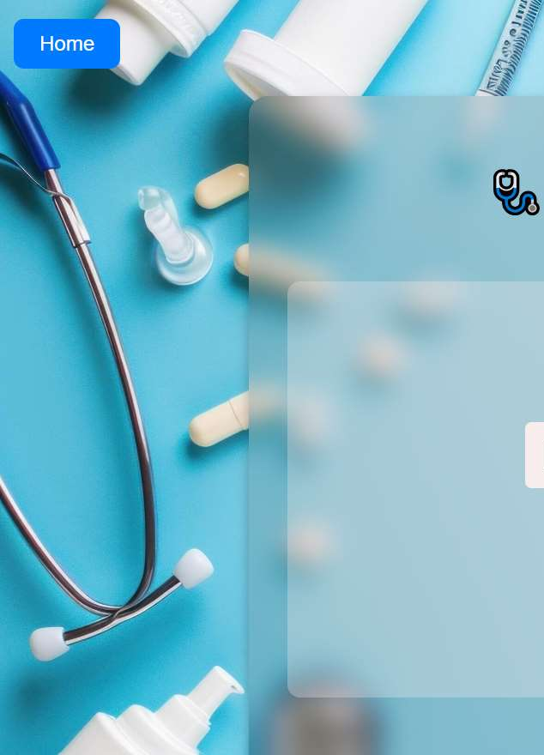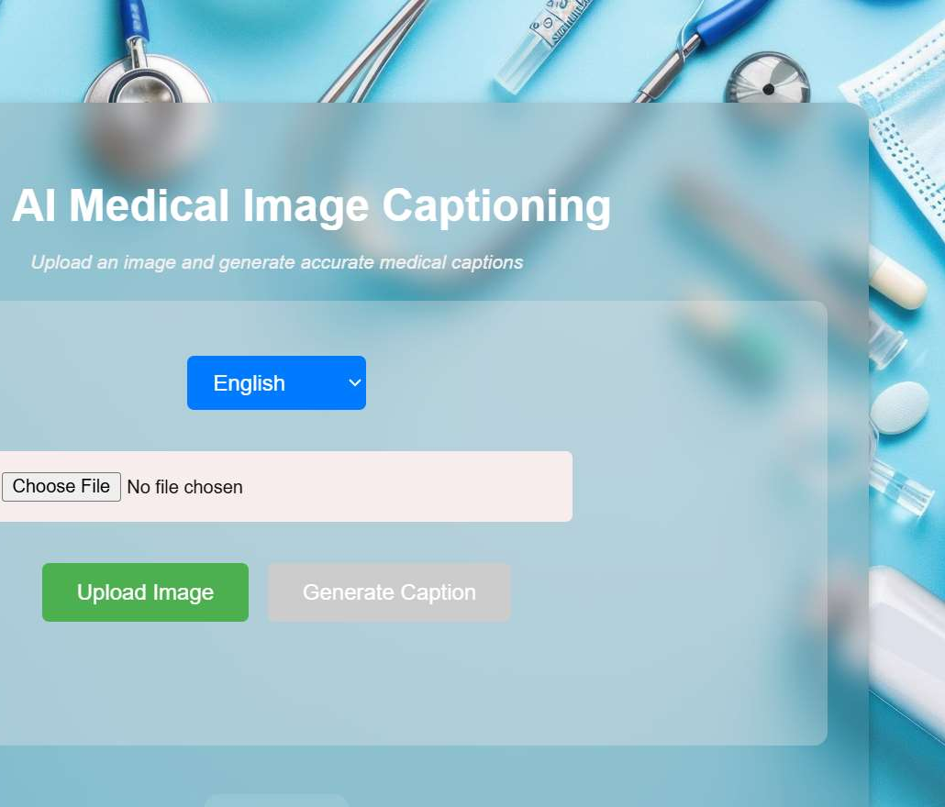

**Figure 1**

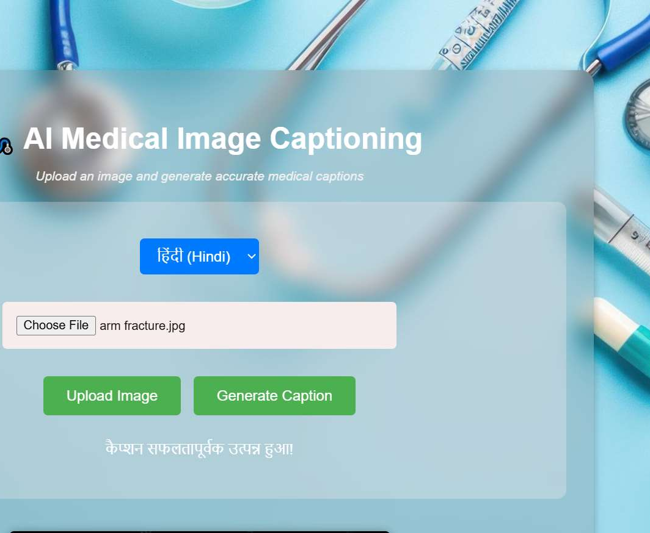

**Figure 2**

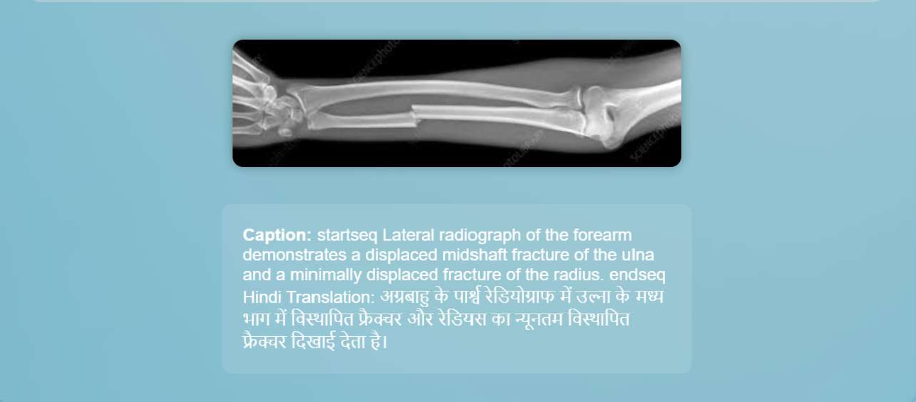

**Figure 3**

**CHAPTER 6: CONCLUSION**

The artificial intelligence-based medical image captioning system is a revolutionary solution to medical image interpretation and documentation challenges. Leveraging Convolutional Neural Networks (CNNs) and Long Short-Term Memory (LSTM) networks with an attention mechanism, the system provides real-time accurate, clinically significant captions. Automation saves time from human intervention in medical image documentation, eliminating human error and achieving maximum efficiency in the clinical environment.

Ease of use and real-time features of the system allow medical practitioners such as radiologists and physicians to document and interpret medical images efficiently and promptly. The solution streamlines the whole process of healthcare through effortless integration with existing healthcare systems and Electronic Health Record (EHR) systems, allowing the medical teams to easily access and address patient data.

Second, it is cloud-based and scalable, and with its excellent data protection capability, it can be deployed at scale across health facilities. Since the system dispenses with the use of manual reports and gives concise yet accurate descriptions, the system not only saves time but also delivers higher levels of diagnostic accuracy, which means improved patient care.

In general, this system represents a major breakthrough in the utilization of artificial intelligence in medicine with great potential for the further growth of medical image processing and clinical decision support systems.